**Project Task:**

**What is snowpipe:**

Snowpipe provides a “pipeline” for loading fresh data in micro-batches as soon as it is available.

**Diagram :**

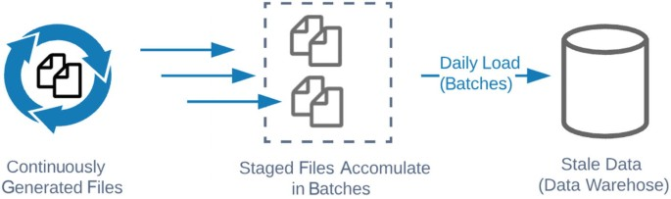

**Features of snowpipe**

* Snowpipe enables loading data from files as soon as they're available in a stage.
* This means you can load data from files in micro-batches, making it available to users within minutes,
* rather than manually executing COPY statements on a schedule to load larger batch
* Snowpipe is Snowflake's continuous data ingestion service.
* Snowpipe loads data within minutes after files are added to a stage and submitted for ingestion.

**Snowsq**l - it is a command line interpreterit is used to copy the file into your local system to snowflake stage.

**Copy into statement for loading json file**

--Put Json file to snowflake code

--create table

create or replace table home_sales (

city string,

zip string,

state string,

type string default 'Residential',

sale_date timestamp_ntz,

price string

);

--create file format

create or replace file format sf_tut_json_format

type = json;

--create stage

create or replace stage sf_tut_stage

--create file format

file_format = sf_tut_json_format;

--put the file to internal storage

PUT file://desktop/sales.json @sf_tut_stage;

--show list @sf_tut_stage;

list @sf_tut_stage;

--Load the JSON data into the relational table.

copy into home_sales(city, state, zip, sale_date, price)

from (select substr($1:location.state_city,4), substr($1:location.state_city,1,2),

$1:location.zip, to_timestamp_ntz($1:sale_date), $1:price

from @sf_tut_stage/sales.json.gz t)

on_error = 'continue';

--continue-continue loading the data

--Query the relational table

select * from home_sales;